Comprehensive User Testing and Validation Plan for a Digital Product

Executive summary
A defensible user testing and validation plan for a moderate-risk digital product should not hinge on a single “5-user” round. ISO 9241-11 defines usability through effectiveness, efficiency, and satisfaction in context, while ISO 9241-210 frames human-centred design as an iterative lifecycle activity grounded in explicit understanding of users and their contexts. In practice, that means using small moderated rounds to find problems early, then running a larger validation round before build commitment. NN/g’s long-standing guidance supports small qualitative rounds for problem discovery, but also distinguishes those from quantitative studies, which require materially larger samples. Faulkner’s replication work is the key caution: some random sets of 5 participants found almost all problems, while other sets found barely over half, so five users can be efficient but unstable. [1]
For the scenario you described, the strongest plan is a staged moderated programme suitable for either remote or in-person testing: a protocol pilot with 2–3 participants, a formative round with 10–12 participants, a short re-test round of 5 participants only if changes are material, and a validation round with 20–30 participants before proceeding to build. That structure balances depth, speed, quota coverage, trust/comprehension testing, and directional benchmarking. It also avoids pretending that 20–30 people create a fully powered population benchmark; NN/g notes that many quantitative comparisons often need 40+ datapoints per condition, especially for inferential comparisons. [2]
This report includes the requested deliverables: sample-size rationale and recruitment criteria; prototype tasks with success criteria and timings; a moderated interview script; quantitative scales for usability, task difficulty, emotional intensity, AI trust, and premium feel; a red-flag checklist; a distress handling protocol; success metrics; revision thresholds; build-readiness criteria; an emotional-intensity method; an AI trust testing method; and boundary and “My OS” comprehension items. The key release logic is simple: do not proceed to build with unresolved severity-4 problems, any unresolved safety/legal/ethical red flags, critical comprehension failures, or evidence of overtrust in AI. Trust must be calibrated, not merely high. [3]
The assumptions below matter. Product specifics are missing, so this plan assumes a general adult audience aged 18–65, English-language moderated sessions, a moderate-risk product, and a concept called My OS that functions as a personalised operating environment organising tools, preferences, and AI assistance around the user. It further assumes that final user authority remains with the user unless explicit automation is turned on. If any of those assumptions are false, some thresholds and test items should be adjusted before fieldwork.

Assumptions and evidence base

Assumptions used in this plan
Assumption | Working interpretation | Consequence for the plan
Audience | General adult users aged 18–65 | Diversity quotas prioritise age, gender, tech-savviness, and socioeconomic spread
Product risk | Moderate-risk digital product | Distress protocol is included, but no clinician is assumed onsite
Platform | No fixed platform | Tasks are platform-neutral; if mobile and desktop are both in scope, test separately or treat platform as a between-subject variable
AI role | AI recommendations and personalisation are present | Trust must be tested through calibrated reliance, not only stated confidence
“My OS” meaning | Personalised operating environment | Comprehension items test what it is, what it is not, what data it uses, and what boundaries govern it
Decision authority | User retains final authority unless explicit automation is enabled | Boundary comprehension items and safety thresholds assume visible override and confirmation controls

Methodological basis
The plan is built on three layers of evidence. First, ISO 9241-11 and ISO 9241-210 set the core foundation: usability must be judged in context, and design should iteratively involve users throughout development. Second, NN/g’s practice guidance supports moderated testing for rich behavioural insight, one task at a time, with careful moderation that avoids leading users. Third, HCI and human-automation research adds two necessary pieces for modern AI products: mental models of system boundaries, and calibrated trust rather than blind trust. Bansal and colleagues show that people perform better with AI when they understand its likely error boundary; Lee and See frame trust as a driver of appropriate reliance; NIST’s AI RMF makes trustworthiness, transparency, safety, accountability, privacy, and fairness explicit evaluation concerns. [4]
For the emotional dimension, this plan uses a short arousal/intensity measure adapted from Bradley and Lang’s Self-Assessment Manikin rather than a long affect inventory. That is deliberate: moderated task-by-task studies need lightweight measures that can be repeated without exhausting participants. For premium-feel assessment, there is no single dominant standard specific to general digital products, so this plan uses a bespoke semantic-differential index informed by visual-aesthetics and hedonic/pragmatic quality research, especially AttrakDiff and related work showing that hedonic and pragmatic quality both shape attractiveness and preference. [5]
Ethics and risk handling are grounded in official research ethics and privacy sources. NHMRC guidance emphasises valid consent, minimising undue influence, recognising signs of reluctance or distress, and respecting a participant’s refusal or wish to withdraw. AHRQ and OHRP both support “teach-back” style comprehension checks for informed understanding. For AI-specific legal and policy risk, NIST, OAIC, and the FTC all point in the same direction: organisations must not hide data use, misstate AI capabilities, or bury material disclosures behind weak notices. [6]

Study design, recruitment, and sample-size rationale

Recommended study structure
The recommended programme is below. It reflects ISO’s iterative stance and NN/g’s distinction between qualitative discovery and larger-sample validation.
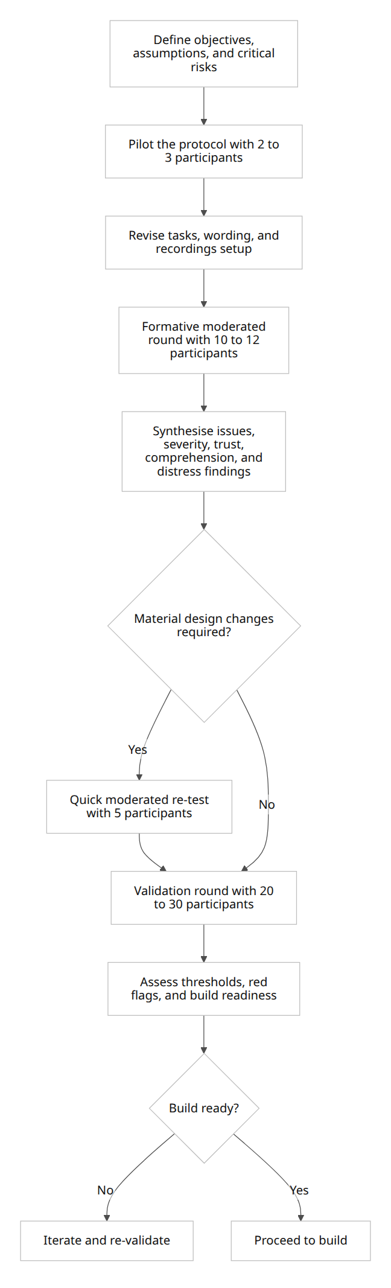
This structure fits both remote and in-person moderated testing. Remote moderated sessions are usually prepared more carefully because meeting tools, device compatibility, privacy, and connection stability can fail; the method is otherwise close to in-person moderated work and offers comparable qualitative depth. [7]

Sample-size options and trade-offs
The table below compares the three sample-size bands you explicitly requested.
Sample size option | Best use | Pros | Cons | Illustrative issue-detection implications | Statistical power implications
5 | Very early discovery or micro re-test after a targeted fix | Fast, cheap, excellent ROI for finding obvious problems quickly | Coverage is unstable; poor quota coverage; unsuitable for go/no-go | ~67% chance of seeing at least one issue affecting 20% of users; ~41% for a 10% issue | Descriptive only; not suitable for population claims or subgroup comparisons
8–12 | Robust formative round | Better coverage, enough room for diversity quotas, more stable severity patterns | Still limited for inferential statistics; smaller subgroup splits become noisy | ~83–93% chance of seeing a 20% issue; ~57–72% for a 10% issue | Good for directional metrics, task benchmarking, and prioritisation; still not a generalisable benchmark
20–30 | Validation-style moderated benchmark before build | Much stronger issue coverage; more stable means; can check directional subgroup gaps | Slower, costlier, still underpowered for many small/medium effect comparisons | ~99–99.9% chance of seeing a 20% issue; ~88–96% for a 10% issue | Good for descriptive validation and large-effect signals; still weaker than a full quantitative benchmark, which often needs ~40+ datapoints per condition
The issue-detection figures above are illustrative author calculations using the standard binomial discovery model discussed in classic usability sample-size work; they are useful for comparing options but should not be mistaken for a guarantee of how many total issues a study will find. Lewis showed why the “5 users find 80%” rule depends heavily on problem-detection probability, and Faulkner showed how unstable five-person subsets can be in practice. NN/g similarly separates small qualitative studies from larger quantitative ones. [8]
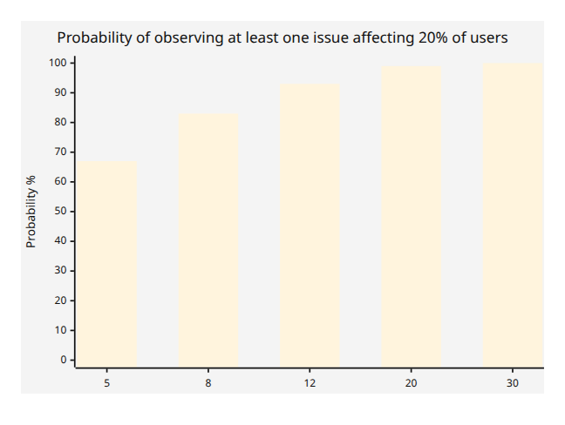
For this product category, the recommended decision is blunt: do not use a 5-user round as the final validation basis. Use 10–12 for the main moderated formative round and 20–30 for the moderated validation round. If leadership wants inferential benchmark claims or reliable subgroup comparisons, the plan should be expanded beyond this brief. [9]

Recruitment criteria, inclusion, exclusion, and quotas
When the target audience is unspecified, the safest default is to recruit to diversity quotas rather than convenience sampling. The quota frame below is appropriate for a general adult population and should be replaced with known market distributions if you have them.
Dimension | Inclusion / exclusion rule | Target quota for 10–12 formative | Target quota for 20–30 validation
Age | Include 18–65 only for this baseline plan | Aim for 2 per band across 18–24, 25–34, 35–44, 45–54, 55–65; flex any extras into underrepresented groups | Aim for 4–5 per band
Gender | Include all genders | No single gender group >60%; include non-binary / another gender where feasible | Same rule; strive for no single category >60%
Tech-savviness | Include low, medium, high digital confidence | Roughly one-third low, one-third medium, one-third high | Same
Socioeconomics | Do not recruit only affluent/tertiary-educated users | At least 30% non-tertiary and/or lower-SES proxy | At least 30% non-tertiary and/or lower-SES proxy
AI familiarity | Important because trust is in scope | If AI is central, aim for 25% low/no use, 50% medium, 25% high | Same, with enough cases to inspect directional differences
Language | English sufficient for current script | English-speaking participants | Same
Prior exposure | Avoid contamination | Exclude anyone who saw earlier prototypes in the same phase unless the objective is longitudinal learning | Validation should ideally exclude prior round participants
Conflicts | Protect validity | Exclude product team, close family/friends, competitors, professional testers | Same
Capacity/wellbeing | Protect consent validity | Exclude participants who appear unable to consent, intoxicated, or currently in acute distress relevant to the study | Same, with stricter screening if content is sensitive
Use simple screener variables. For tech-savviness, ask for self-rated confidence changing settings, frequency of using new digital products, and frequency of using generative AI or automation. For socioeconomic diversity, prefer respectful proxies such as education, occupation, or postcode-level SES band over intrusive financial interrogation unless income is genuinely decision-relevant. If the actual market is known, replace these fallback quotas with market-matching quotas and keep the low-tech and lower-SES floors. This approach is consistent with the human-centred requirement to understand users in context rather than defaulting to whoever is easiest to recruit. [10]

Recruitment operations, incentives, and backups
Use the same screener for every participant and every backup participant. If schedule certainty matters, over-recruit one floater for every two scheduled interviews. NN/g’s guidance is explicit that backups should be recruited to the same screening criteria and paid at least as much as regular participants. Compensation should be disclosed in advance, prorated where appropriate, and not converted into a completion-only bonus that pressures people to continue when distressed; NHMRC guidance treats minimising undue influence as a live requirement, not a paperwork exercise. [11]
For remote sessions, screen for device compatibility, permission to screen-share, reliable internet, and a quiet private location. For in-person sessions, use the same screener, but add travel logistics and waiting-space planning. Either way, use market-appropriate incentives and confirm reminders 24 hours and 2 hours before the session. [12]

Prototype task plan and moderated guide

Session structure
A 60–75 minute moderated session is appropriate for this plan. That is long enough to cover behavioural tasks, trust and comprehension checks, and post-task ratings, without turning the session into a fatigue exercise.
Segment | Typical time | Output
Welcome, framing, consent | 5–7 min | Valid consent, participant at ease
Warm-up interview | 5 min | Prior habits, expectations, AI familiarity
Core behavioural tasks | 30–40 min | Task success, time, errors, observations
AI trust and boundary challenge items | 8–10 min | Reliance, verification, mental-model evidence
Post-test scales | 5–7 min | SUS, premium feel, trust summary
Debrief and wellbeing check | 5–6 min | Qualitative wrap-up, distress check, close
NN/g advises moderators to use a guide, give tasks one at a time, introduce think-aloud if used, and avoid turning the session into a chatty conversation that contaminates observation. The script below follows that model. [13]

Prototype task list
The tasks below are written as adaptable templates. Replace bracketed text with the product’s actual high-frequency user goal, data settings labels, and AI recommendation types.
Task | Participant prompt | Success criteria | Expected time
First impression and value comprehension | “You have just arrived here for the first time. Without clicking yet, tell me what you think this product is, what ‘My OS’ means, and what you expect it can help you do. Then proceed if you would continue.” | Participant can describe the core value proposition in plain language, identify the main next step, and does not fundamentally misread “My OS” | 2–3 min
Onboarding and permissions | “Set up My OS so it works for you. Choose the options you want and decide which permissions you are comfortable giving.” | User completes setup, distinguishes required from optional permissions, and can explain at least one permission consequence | 5–7 min
Personalise the environment | “Adjust My OS so it prioritises [Goal A] over [Goal B], and make the home experience reflect that.” | User changes preferences successfully and sees the effect reflected in the interface | 4–5 min
Complete a core workflow | “Use My OS to complete [top-frequency user task].” | User completes the main flow without moderator intervention | 5–6 min
Inspect an AI recommendation | “My OS suggests [action]. Work out why it suggested this and decide whether you would accept it.” | User can find explanation or rationale, understand enough context to decide, and articulate why they accepted or rejected it | 5–6 min
Override and teach the system | “Assume this recommendation is wrong for you. Correct it, and if possible prevent similar mistakes in future.” | User can override, undo, edit preference or provide feedback, and understand how to shape future behaviour | 5–6 min
Change privacy and autonomy boundaries | “Limit what My OS uses for personalisation and make it ask before taking a higher-impact action.” | User finds privacy/autonomy settings, changes at least two controls, and explains the effect correctly | 4–5 min
Find limits, support, and exit controls | “Show me where you would check what My OS can and cannot do, and where you would go if you wanted help, to pause a feature, leave, or delete history/data.” | User locates help or limits information and finds the relevant support/exit/data-control path | 4–5 min
Optional stress scenario for emotional-intensity testing | “An important recommendation now conflicts with something that matters to you. Decide what you would do next.” | User verifies before acting, avoids blind acceptance, and uses the available control or help route if uneasy | 4–5 min
Good task scenarios should be realistic, goal-based, and non-leading. They should describe what the participant wants to achieve, not tell them which control to click. [14]

Moderated interview script

Intro and consent
Segment | Suggested moderator wording
Welcome | “Thanks for joining. Today we’re evaluating this product concept, not you. Some parts may still be incomplete or rough. You won’t hurt anyone’s feelings by being candid.”
Framing | “I didn’t design this interface personally, so please be blunt. What helps us most is what you expect, what surprises you, and what feels unclear.”
Method | “I’ll ask you to work through a few realistic tasks and, where possible, say out loud what you’re trying to do, what you expect to happen, and anything that feels confusing.”
Recording | “With your permission, I’d like to record the session so the team can review what happened accurately. The recording is for research only.”
Voluntary participation | “Your participation is voluntary. You can pause, skip a question, take a break, or stop the session at any time. If anything feels uncomfortable, please say so immediately.”
Consent check | “Do you consent to take part and to recording under those conditions?”
This script deliberately uses the language of “research” or “study” rather than framing the session as a test of the participant, which NN/g recommends because “test” can make participants feel judged. [15]

Warm-up and baseline questions
Topic | Suggested wording
General behaviour | “Tell me about the last time you used a digital product to organise your work, time, or priorities.”
Personalisation habits | “How comfortable are you changing settings, preferences, or automation in products you use?”
AI familiarity | “How often do you use AI tools or recommendations, and what determines whether you trust them?”
Boundary baseline | “When a system says it is personalised, what do you usually assume that means?”
Emotional baseline | “Before we start, how calm or activated do you feel right now on a 1-to-7 scale?”

Task handoff language
Use the following structure for every task:
“I’ll read the task once, then I’ll stay mostly quiet unless you become badly stuck or there’s a technical problem. Please approach it the way you would on your own.”
Then read the prompt verbatim from the task list.

Neutral probes during tasks
Use only neutral prompts unless the distress protocol activates.
Situation | Preferred neutral probe
User pauses | “What are you looking for right now?”
User hesitates | “What did you expect to happen here?”
User asks “What should I do?” | “What would you do if you were at home and I wasn’t here?”
User seems confused | “What is the system communicating to you at this point?”
User accepts AI quickly | “What made that feel safe to trust?”
User rejects AI quickly | “What made you doubt it?”
User finds a setting | “What do you think changing that will do?”
NN/g’s moderation advice is to talk less, learn more, and avoid answering in ways that lead the participant. The “echo / boomerang / Columbo” style facilitation techniques are designed precisely for this situation. [16]

Post-task prompts
Ask immediately after each task:
- “How easy or difficult was that task on a 1-to-7 scale?”
- “How emotionally intense did that feel on a 1-to-7 scale?”
- “How confident are you that you understood what My OS was doing there?”
- For AI tasks only: “How much would you trust My OS in a similar situation?”

Debrief
Topic | Suggested wording
Overall reflection | “What felt most useful? What felt least trustworthy?”
Mental model | “In your own words, what is My OS actually doing for you, and where are its limits?”
Control and safety | “If this system made a recommendation you disagreed with, how confident are you that you could correct or override it?”
Premium feel | “Did this feel basic, competent, or premium? Why?”
Distress/wellbeing close | “Before we finish: are you feeling okay, and is there anything from the session you’d prefer not to discuss further?”
Final thanks | “Thank you. Your feedback helps us improve the product, especially the parts that were unclear or uncomfortable.”

Measurement framework

Quantitative scales, anchors, and scoring
The framework below uses a mix of standard and bespoke instruments. Standard where it matters; bespoke where the literature is useful but no single off-the-shelf scale fully matches the construct.
Construct | Instrument | Timing | Anchors | Scoring
Usability | SUS using the canonical 10-item wording | End of session | 5-point agreement from strongly disagree to strongly agree | Standard SUS scoring: odd items = raw minus 1; even items = 5 minus raw; sum and multiply by 2.5 for a 0–100 score
Task difficulty | Single Ease Question style rating reported as ease, with optional reverse-coded difficulty | After every task | 1 = very difficult, 7 = very easy | Report raw ease; if a difficulty score is needed, use 8 - ease
Emotional intensity | Adapted short arousal scale informed by SAM | Baseline, after selected tasks, end-of-session recovery | 1 = very calm / no emotional activation; 7 = overwhelming / too intense | Use raw score, peak score, peak-minus-baseline delta, and end-of-session recovery score
AI trust | Bespoke 5-item calibrated trust scale informed by trust-in-automation research | After AI-mediated tasks and end of session | 1 = strongly disagree, 7 = strongly agree | Average items, convert to 0–100 if needed; interpret jointly with behavioural calibration, not alone
Premium feel | Bespoke 6-item semantic differential informed by visual-aesthetics / hedonic-quality work | After first impression and end of session | 1 at the negative pole, 7 at the positive pole | Average items, convert to 0–100
SUS remains a sound choice because it is brief, widely used, and specifically designed as a low-cost global usability measure. Brooke also explicitly links its use to the ISO framing of effectiveness, efficiency, and satisfaction. The task-level ease measure keeps cognitive load low during moderated sessions. Emotional intensity uses the arousal logic of SAM because it is fast and repeatable. AI trust and premium feel are bespoke here because the product category requires calibrated trust and a specific perception of quality that no single packaged scale fully covers. [17]

AI trust items and method
Use the following 5 statements after AI-reliant tasks and once again at the end of the session.
Item | Statement
Trust item | “I found My OS reliable for this task.”
Trust item | “I could predict what My OS was going to do.”
Trust item | “I understood why My OS made that recommendation.”
Trust item | “I believed My OS stayed within the boundaries it had stated.”
Trust item | “I would feel comfortable relying on My OS for a similar low-to-moderate stakes task.”
Scoring: average the 5 items on a 1–7 scale; optionally convert to 0–100 with ((mean - 1) / 6) * 100.
Interpretation:
- below 50: low trust / likely confusion or unreliability
- 50–69: cautious, mixed trust
- 70–84: healthy trust range if calibration is also good
- 85+: only acceptable if calibration is also good; otherwise suspect overtrust
Do not stop at self-report. Trust should be tested behaviourally through calibration challenges. Present four AI challenge items during or after tasks: two recommendations that are intentionally strong and well-supported, and two that are intentionally weak, ambiguous, or poorly justified but still safe to simulate. For each one, record whether the participant accepts, verifies, overrides, or rejects it, and why.
Behavioural trust metric | Formula | Meaning
Calibration Rate | Appropriate responses / total challenge items | Overall appropriateness of reliance
Overtrust Rate | Weak recommendations accepted without verification / weak items | Dangerous willingness to rely when the signal is poor
Undertrust Rate | Strong recommendations rejected despite clear support / strong items | Failure to benefit from valid automation
Boundary Recall | Critical boundary items answered correctly / boundary items administered | Whether trust is built on an accurate mental model
This two-layer method matters because explanations can improve understanding but can also increase over-reliance. Trust literature consistently argues for appropriate reliance rather than simply increasing confidence. NIST’s AI RMF reinforces the need to measure validity, reliability, safety, transparency, explainability, accountability, privacy, and managed bias together, not in isolation. [18]

Emotional-intensity method
Use emotional-intensity checks at four points: baseline, after the permission/onboarding task if sensitive, after the stress/error-boundary task, and at session close.
Metric | How to capture it | Why it matters
Baseline intensity | 1–7 before tasks | Establish participant’s starting state
Task peak intensity | 1–7 after emotionally salient tasks | Detect activation triggered by the concept or interaction
Peak delta | Peak minus baseline | Distinguish product-triggered change from pre-existing state
Recovery score | 1–7 at session end | Detect whether activation settles or lingers
Observed distress markers | Moderator notes behaviourally salient markers | Catch cases where self-report understates distress
Use this anchor wording:
- very calm / no emotional activation
- calm
- slightly activated
- noticeable but manageable
- strong emotional activation
- very intense
- overwhelming / I would prefer to stop
Bradley and Lang’s work supports quick arousal assessment, while NHMRC ethics guidance makes participant discomfort and distress a live moderation issue rather than a post-hoc note. For moderate-risk products, this is enough. For higher-risk products, it is not. [19]

Premium-feel assessment items
Administer this twice: once after the first-impression task and once after the full session. The score decay between those two moments is informative: some products look premium until the user actually tries them.
Item pair | Scale
Cheap — Premium | 1–7
Generic — Distinctive | 1–7
Rough — Polished | 1–7
Fragmented — Cohesive | 1–7
Basic — Thoughtfully crafted | 1–7
Not worth paying for — Worth paying for | 1–7
Scoring: average all six items and convert to 0–100 if needed.
This is a bespoke index, but it is not arbitrary. The literature behind it is the visual-aesthetics and hedonic/pragmatic quality tradition: spiritual descendants of AttrakDiff, visual aesthetics work, and the “what is beautiful is usable” line of HCI findings. The point is not luxury theatre. The point is whether the interface feels well-considered, cohesive, and worth commitment. [20]

Boundary comprehension and My OS comprehension test items
Use two short comprehension checks: one for boundaries and one for what My OS actually is. These are best administered as teach-back plus scored items. Where a product claim is not yet fixed, replace the placeholder with the final disclosed behaviour before launch testing.

Boundary comprehension items
Item | Type | Expected correct answer | Critical
“Who makes the final decision when My OS gives a recommendation?” | Short answer | The user, unless explicit automation was enabled | Yes
“If My OS sounds confident, does that mean it is guaranteed to be correct?” | Yes / No | No | Yes
“Before My OS takes a higher-impact action, what should happen?” | Multiple choice / teach-back | Confirmation unless the user explicitly enabled that automation | Yes
“Where would you go to see or change what data My OS uses?” | Short answer | Privacy / personalisation settings or equivalent disclosed control | Yes
“If My OS gives a recommendation you think is wrong, what are two safe things you can do?” | Short answer | Verify why / inspect explanation / override / edit preferences / seek help | Yes
“Can My OS use your data in a way the product explicitly promised not to?” | Yes / No | No | Yes

My OS comprehension items
Item | Type | Expected correct answer | Critical
“In one sentence, what is My OS?” | Open recall | A personalised operating environment that organises the experience around the user’s preferences and assistance settings | Yes
“What changes when you update your preferences or goals?” | Short answer | Recommendations, prioritisation, layout, or automation behaviour should change | No
“How would you check why a recommendation or card is appearing?” | Short answer | Use explanation / details / why-this-is-shown pathway | Yes
“How would you correct My OS after a bad suggestion?” | Short answer | Override, feedback, preference change, or boundary update | Yes
“What is the difference between personalisation and automatic action?” | Short answer | Personalisation changes what is shown / suggested; automatic action executes something | Yes
“If you wanted less personalisation, what would you do?” | Short answer | Use settings to reduce data use, turn off personalisation, or tighten permissions | Yes
Scoring rule: 1 point per correct item. Pass threshold: 80% overall on each set, with 100% on critical items. If a participant says “I’m not sure”, score that as incorrect. For open items, use a simple rubric agreed before fieldwork.
Teach-back and comprehension checks are not overkill here. They are the direct way to confirm that apparent understanding is real, especially when the product makes claims about AI, data use, autonomy, or boundaries. [21]

Risk management, decision rules, and build readiness

Red-flag checklist
Use the following checklist after every session and in the synthesis workshop. Any severity-4 event should immediately block a build decision.
Category | Red flag | Default severity | Required response
Critical usability | User cannot start a core task or consistently misreads the first action | 3–4 | Redesign entry point before next round
Critical usability | User cannot undo, recover, or exit a mistaken path | 4 | Block progression until fixed
Critical usability | User cannot find privacy, autonomy, or data controls | 4 | Block progression until fixed
Safety | User accepts a poor recommendation because confidence cues imply certainty | 4 | Redesign trust and explanation cues
Safety | Higher-impact action can occur without clear confirmation or override | 4 | Block progression until fixed
Safety | Error states provide no safe fallback, help, or escalation path | 4 | Add safe recovery and support route
Legal | Claims imply unsupported capability, superiority, fairness, or reliability | 4 | Remove or substantiate before testing further claims
Legal | Data use, retention, or model-improvement use is hidden, vague, or contradicted by UI copy | 4 | Rework disclosures and controls
Legal | Consent or settings nudges users into broader data use than they intended | 4 | Redesign to remove dark-pattern pressure
Ethical | Interface anthropomorphises AI in a way that obscures actual capability or responsibility | 3–4 | Reword and reframe boundaries
Ethical | User cannot understand when the system is acting, suggesting, or merely reordering | 3–4 | Clarify system state and agency
Distress | Crying, panic, freezing, visible shame/self-blame, voice breaks, or repeated apologies linked to the task | 4 for session handling | Pause immediately and activate distress protocol
NN/g’s severity framework is still useful here because it forces teams to combine impact, frequency, and persistence rather than arguing from opinions. For AI products, NIST, OAIC, and FTC guidance make safety, transparency, privacy, accountability, and truthful claims non-negotiable. [22]

Distress handling protocol
This protocol is designed for a moderate-risk product. It is not sufficient for crisis, therapy, health, legal, financial, or other high-consequence domains.
Step | Moderator action | Suggested wording
Recognise | Stop observing silently and acknowledge distress | “Let’s pause there.”
Normalise | Remove performance pressure | “You’re not doing anything wrong. We’re evaluating the design, not you.”
Offer control | Offer immediate options | “Would you like to stop, skip this part, take a short break, or continue with a different task?”
Reduce demand | Remove the triggering task or lower cognitive load | Switch task, hide the screen, or move to verbal debrief
Check immediate state | Confirm whether participant feels able to continue | “How are you feeling right now?”
Respect refusal | If the participant wants to stop, stop | End session without penalty
Provide support route | Give the agreed support information if needed | “I’ll close the session now and send the follow-up we discussed.”
Document and escalate | Log trigger, behaviour, resolution, and whether data should be retained | Study lead reviews within 24 hours
Two operational rules matter. First, incentives should not depend on completion, because that can subtly trap distressed participants in the session. Second, if remote testing is used, moderators should have a callback method and know the participant’s general location at session start for emergency escalation if behaviour suggests imminent harm. NHMRC guidance is clear that discomfort, distress, and valid consent are active duties, not formalities. [23]

Success metrics and thresholds
The thresholds below are managerial release gates, not universal laws. They are intentionally stricter than “good enough to learn something” because they are meant to support a build decision.

Task-level thresholds
Metric | Threshold for core tasks | Threshold for safety / privacy / boundary tasks
Unaided task success | ≥85% | ≥90%
Assisted success | ≥95% | 100%
Median time on task | ≤1.5 × expected time | ≤1.5 × expected time
Participants taking >2 × expected time | ≤20% | ≤10%
Mean task ease | ≥5.5 / 7 | ≥5.0 / 7
Severity-4 failures | 0 | 0
Recurrent severity-3 issue clusters | ≤1 affecting <10% of participants | 0 unresolved

Product-level thresholds
Metric | Validation threshold
SUS | ≥80 / 100
AI Trust Score | 70–84 / 100, interpreted only alongside calibration
Calibration Rate | ≥75%
Overtrust Rate | <10%
Emotional-intensity median peak | ≤4 / 7
Participants hitting 6–7 intensity | ≤10%, with no unresolved harm trigger
Recovery score at end | ≤3 / 7 for ≥90% of participants
Boundary comprehension | ≥80% overall and 100% on critical items
My OS comprehension | ≥80% overall and 100% on critical items
Premium Feel Index | ≥70 / 100 if premium positioning is part of the promise
Subgroup gap on core success or comprehension | No gap >15 percentage points
These thresholds are consistent with ISO’s effectiveness/efficiency/satisfaction triad, trust-calibration research, and NIST’s view that trustworthy AI must be valid, reliable, safe, transparent, accountable, privacy-enhancing, and fair. [24]

Revision thresholds
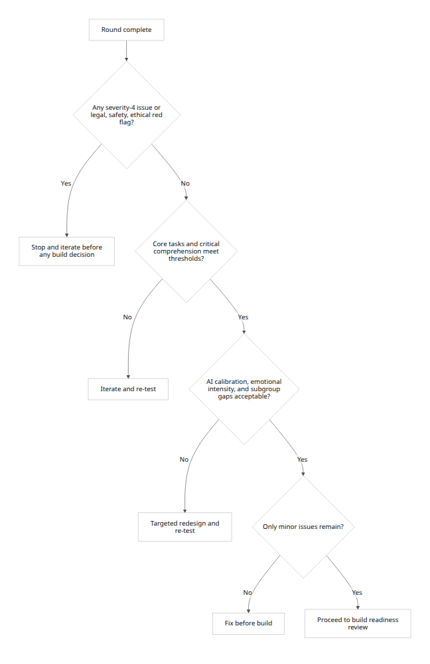
Use the following explicit decision table.
Condition | Decision
Any severity-4 usability failure | Iterate immediately
Any unresolved safety, privacy, legal, or ethical red flag | Iterate immediately
Critical comprehension item missed by any meaningful cluster of users, or by a single participant if the item is safety-critical and the UI strongly implied the wrong answer | Iterate immediately
Core task success 70–84%, or AI calibration 60–74%, or premium feel below threshold when premium positioning is core to the proposition | Iterate and re-test before validation sign-off
All core thresholds passed, no critical red flags, only low-severity cosmetic friction remains | Proceed to build-readiness review

Build-readiness criteria
Proceed to build only if all criteria below are met.
Category | Build-ready criterion
Evidence | Validation round complete with required quotas and thresholds met
Usability | No unresolved severity-4 issues; no unresolved severity-3 issue on safety, privacy, autonomy, or recovery tasks
AI trust | Trust is calibrated: acceptable trust score and acceptable calibration rate, with low overtrust
Comprehension | Critical boundary and My OS items are understood at the required thresholds
Safety / ethics / legal | Claims, disclosures, permission controls, override pathways, and data controls have all been tested and understood
Emotional safety | No unresolved concept- or flow-induced distress pattern
Equity | No major subgroup gap across age, gender, tech-savviness, or SES proxies on critical tasks
Operational readiness | Help content, escalation ownership, incident logging, and rollback/fallback behaviour are defined
Measurement | Post-launch instrumentation exists for task success, override behaviour, complaints, and help usage
For AI systems specifically, NIST’s GOVERN, MAP, MEASURE, and MANAGE framing maps cleanly onto this gate: build should follow only after risks have been identified, measured, communicated, and assigned to named owners. “We’ll fix it later” is not a build-readiness criterion. [25]

Open questions and limitations
This plan is intentionally rigorous, but it still rests on missing product specifics. The largest unknowns are the exact domain, the actual consequence level of AI recommendations, the launch geography, the exact data and model-use disclosures, and whether “My OS” merely personalises or can also execute actions autonomously. Those details materially affect the wording of the comprehension items, the red-flag checklist, and the release thresholds. If the product touches health, finance, employment, legal advice, minors, crisis support, or any high-consequence decision, this moderate-risk plan is not enough. In that case, raise critical-task thresholds to 95–100%, run specialist ethics and legal review, recruit the actual high-risk user segments directly rather than relying on a general-adult sample, and use a stronger distress/escalation protocol with domain-qualified oversight. [26]

[1] [4] [24] ISO 9241-11:2018 - Ergonomics of human-system interaction — Part 11: Usability: Definitions and concepts
https://www.iso.org/standard/63500.html?utm_source=chatgpt.com
[2] [7] [12] Remote Moderated Usability Tests: How to Do Them - NN/G
https://www.nngroup.com/articles/moderated-remote-usability-test/?utm_source=chatgpt.com
[3] [22] Severity Ratings for Usability Problems: Article by Jakob Nielsen - NN/G
https://www.nngroup.com/articles/how-to-rate-the-severity-of-usability-problems/?utm_source=chatgpt.com
[5] [20] AttrakDiff
https://www.attrakdiff.de/sience-en.html?utm_source=chatgpt.com
[6] [19] National-Statement-on-Ethical-Conduct-Human-Research- ...
https://www.nhmrc.gov.au/sites/default/files/documents/attachments/publications/National-Statement-on-Ethical-Conduct-Human-Research-2025.pdf?utm_source=chatgpt.com
[8] (PDF) Sample Sizes for Usability Studies: Additional Considerations
https://www.researchgate.net/publication/15128047_Sample_Sizes_for_Usability_Studies_Additional_Considerations?utm_source=chatgpt.com
[9] How Many Participants for Quantitative Usability Studies: A Summary of Sample-Size Recommendations - NN/G
https://www.nngroup.com/articles/summary-quant-sample-sizes/?utm_source=chatgpt.com
[10] ISO 9241-210:2019 - Ergonomics of human-system interaction — Part 210: Human-centred design for interactive systems
https://www.iso.org/standard/77520.html?utm_source=chatgpt.com
[11] Recruiting Backup Participants (aka “Floaters”) in User Research - NN/G
https://www.nngroup.com/articles/recruit-backup-users-in-research/?utm_source=chatgpt.com
[13] [15] Checklist for Moderating a Usability Test - NN/G
https://www.nngroup.com/articles/usability-checklist/?utm_source=chatgpt.com
[14] Task Scenarios for Usability Testing - NN/G
https://www.nngroup.com/articles/task-scenarios-usability-testing/?utm_source=chatgpt.com
[16] Talking with Users in a Usability Test - NN/G
https://www.nngroup.com/articles/talking-to-users/?utm_source=chatgpt.com
[17] SUS - A quick and dirty usability scale
https://digital.ahrq.gov/sites/default/files/docs/survey/systemusabilityscale%2528sus%2529_comp%255B1%255D.pdf?utm_source=chatgpt.com
[18] How the different explanation classes impact trust calibration: The case of clinical decision support systems - ScienceDirect
https://www.sciencedirect.com/science/article/pii/S1071581922001616?utm_source=chatgpt.com
[21] Use the Teach-Back Method: Tool 5 | Agency for Healthcare Research and Quality
https://www.ahrq.gov/health-literacy/improve/precautions/tool5.html?utm_source=chatgpt.com
[23] Payment of participants in research: information for researchers, HRECs and other ethics review bodies
https://www.nhmrc.gov.au/sites/default/files/documents/attachments/publications/Payment-of-participants-in-research.pdf?utm_source=chatgpt.com
[25] [26] Artificial Intelligence Risk Management Framework (AI RMF 1.0)
https://nvlpubs.nist.gov/nistpubs/ai/nist.ai.100-1.pdf?utm_source=chatgpt.com

